GENERAL INFORMATION

The 10th Empirical Investigations in Trade and Investment (EITI) Conference
Organized by
Fukunari Kimura (ERIA, Keio University, FREIT) and Jon Haveman (FREIT)
Sponsored by
Economic Research Institute for ASEAN and East Asia (ERIA) and Keio University
URL: http://www.freit.org/EITI/2015/

Sofitel Plaza Hotel, Hanoi, Vietnam

10 – 12 March 2016

As of 28 October 2015
Item | Description
Date & Time of the Conference | Thursday - Saturday, 10 – 12 March 2016 (a two and half day conference).  09 March 2016: Arrival day  10 - 11 March 2016: Full day meeting (08.00 – 17.00)  12 March 2016: Half day meeting (08.00 – 13.00)  Tentative Program of Activities is to be sent later.
Venue of the Conference | Sofitel Plaza Hanoi  1 Thanh Nien Street,  Ba Dinh District, Hanoi, Vietnam  +84 4 3823 8888 (http://www.accorhotels.com/gb/hotel-3553-sofitel-plaza-hanoi/index.shtml)
Air Ticket | - We will provide a round-trip discount-economy-class air ticket upon your request, from your country of origin to the Conference venue.  - We will avoid any cancellation or additional fee of any schedule changes once the ticket has been issued. Should there will be any, it would be borne by you. Therefore, please kindly ensure your firm schedule to minimize the possibility of penalty fee.  - For the arrangement of your airline ticket, you will be contacted by:  Ms. Puput Putri Parida (Puput)  Tel. (62)-21-5797-4460 Ext. 504; Fax. (62)-21-5797-4464  Mobile Phone : (62)-815-1301-7852  Email: puput.putri@eria.org
Passport & Travel Visa | - Your passport must have at least six-month validity.  - Free visa is possible for nationals of the following 23 countries and territories: Belarus, Brunei Darussalam, Indonesia, Cambodia, Denmark, Finland, France, Germany, Indonesia, Italy, Japan, Kyrgyzstan, Laos, Malaysia, Myanmar, Norway, Philippines, Russia, Singapore, South Korea, Spain, Sweden, Thailand, and United Kingdom.  (source: http://www.vietnamvisa-easy.com/pages/vietnam-visa-exemption )
Daily Subsistence Allowance (DSA) | - We will provide DSA during your stay in Hanoi (in connection to the event’s activities).  - DSA will be paid in US$ cash directly to you at the Conference venue.
Accommodation | - We will reserve a single-occupancy room (Including breakfast and internet) in Sofitel Plaza Hanoi (same as Venue of the Conference) for each participant.  Type of Room : Sofitel Luxury Room  Room Rate : USD138nett / room / night (Inclusive of Service charge and government tax, Breakfast, and Internet)  Check-in time : 1400 hrs  Check-out time: before 1200 hrs  - We will settle the payment directly to the hotel for the room cost only.  - Any incidentals or personal expenses occur, it will be shouldered to the participants.  - Early check-in policy:  From 0700 hrs to 1359 hrs, 50% of the room rate.  From 0001 hrs to 0659 hrs, 100% of the room rate.  Late check-out policy:  From 1201 hrs to 1800 hrs, 50% of the room rate.  After 1801 hrs, 100% of the room rate.
Transportation from Airport to Hotel | - The Hotel provides transportation from the airport to hotel  Should you need the arrangements, we will assist you. However, the cost will be borne by you.  By car (Max 7 persons) : USD 50.00,- per way  - You may use Taxi to commute to the hotel. A taxi stand is located outside Hanoi Airport.  The average range of cost of taxi is around approx. USD 11.50,-  Please inform to the taxi driver to take you to Sofitel Plaza Hanoi
Others | If you plan to come with your co-author(s), please inform us. We may have budget ample enough to cover his/her travel cost on a limited basis.
ERIA Contact Person | Prof. Fukunari Kimura  Email: vzf02302@nifty.ne.jp  Ms. Puput Putri Parida (Puput)  Tel. (62)-21-5797-4460 Ext. 504; Fax. (62)-21-5797-4464  Mobile Phone : (62)-815-1301-7852  Email: puput.putri@eria.org

The Map of Sofitel Plaza Hanoi

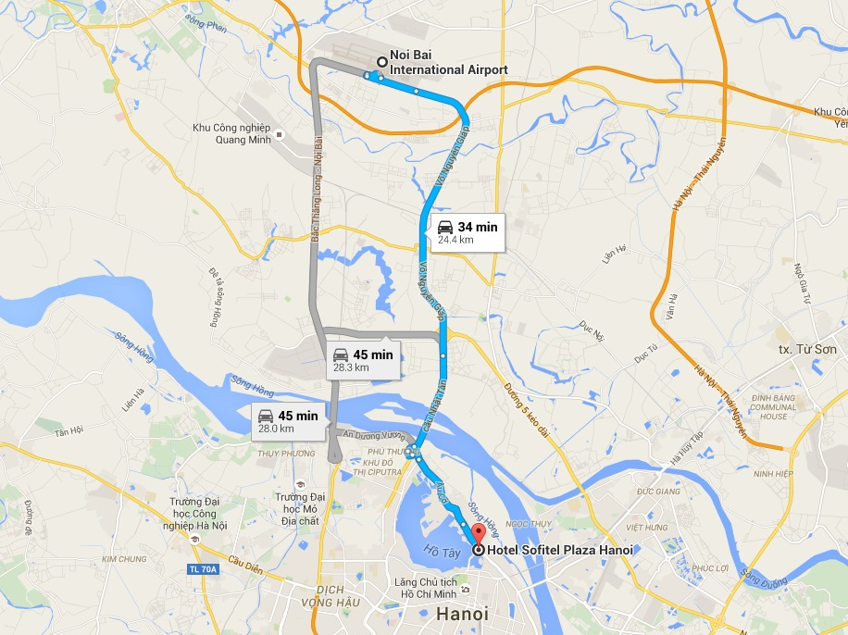

The Map of Noi Bai International Airport

